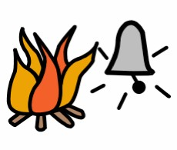**What to do in a Lock Down ……..**

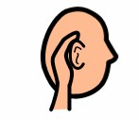

**When YOU hear Loud Continuous Bells**

**uous**

[](http://www.google.com.au/url?sa=i&rct=j&q=&esrc=s&frm=1&source=images&cd=&cad=rja&docid=YyuOas48--rZlM&tbnid=55wHEW0t7RZhtM:&ved=0CAUQjRw&url=http://www.google.com.au/url?sa=i&rct=j&q=&esrc=s&frm=1&source=images&cd=&docid=YyuOas48--rZlM&tbnid=55wHEW0t7RZhtM:&ved=&url=http://stockfresh.com/image/482105/ringing-mobile-phone-icon-vector-illustration&ei=9C53UYeICtSeiQeUw4DYCg&bvm=bv.45580626,d.aGc&psig=AFQjCNFYni2q6rwQPXbPI6Gr9Iy7_bqS1A&ust=1366851700512904&ei=RTB3UZPdMuuyiQe_mICgAw&bvm=bv.45580626,d.aGc&psig=AFQjCNFYni2q6rwQPXbPI6Gr9Iy7_bqS1A&ust=1366851700512904)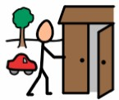******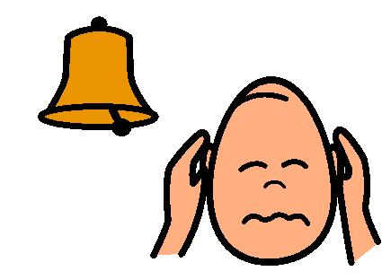**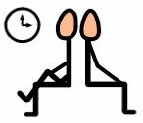

**If you are told by your teachers or if you hear an intermittent bell**

**It is All Clear**

**IF**

**You are in the playground during recess, lunch, breaks**

**IF**

**You are in *any* classroom, laboratory the library or**

**during class time**

**Move to HALL**

**OR**

**Stay in or Move to Nearest Classroom.**

**.**

**Don’t get frightened**

**Follow your teacher’s directions and move away from doors and windows**

**Turn off Mobile Phone**

**Wait and Do Not Leave**