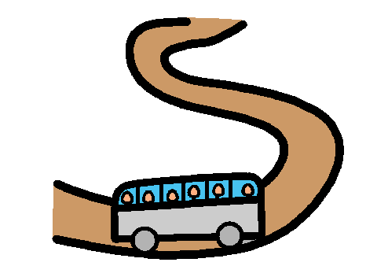
Eddy is going on an excursion.
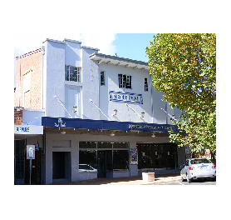
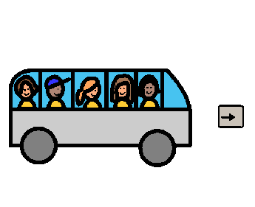

Eddy is going to the
Montreal Theatre in the bus.

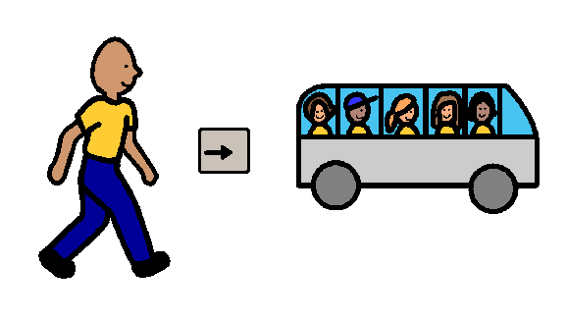
Eddy will get in the bus.
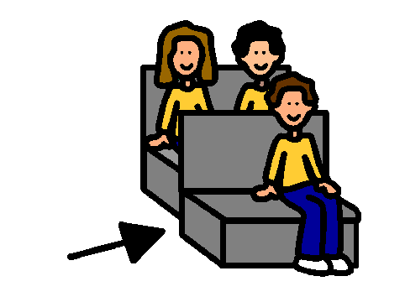
Eddy will sit quietly in the bus.
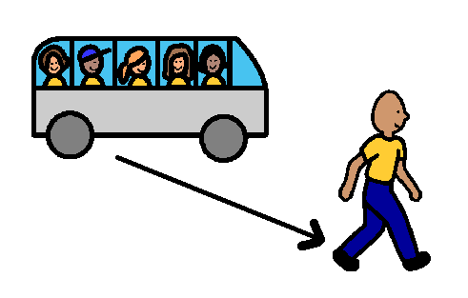
Eddy will get out of the bus when asked.
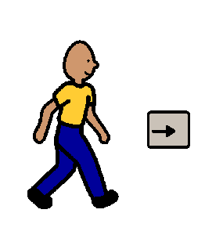

Eddy will walk to the theatre.

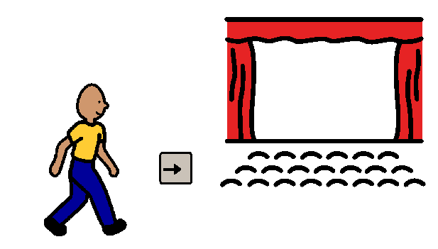
Eddy will walk to his seat quietly.

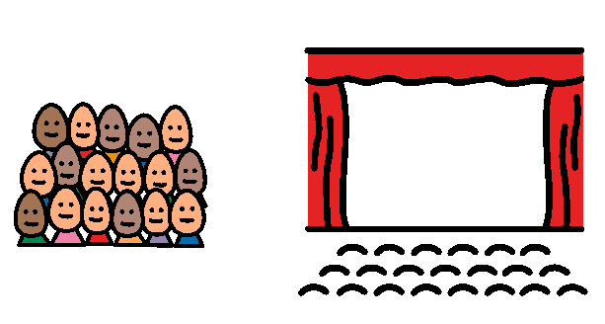
Eddy will watch the show quietly.
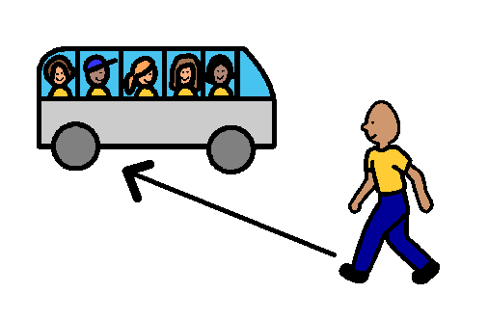
When the show is finished
Eddy will walk to the bus.
Eddy will sit quietly in the bus.
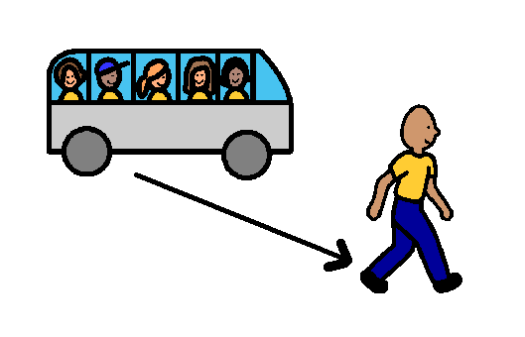
When the bus gets back to school
Eddy will get out of the bus.

