Eddy is going shopping.

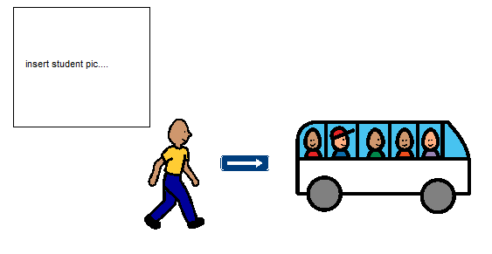
Eddy will walk quietly to the bus.
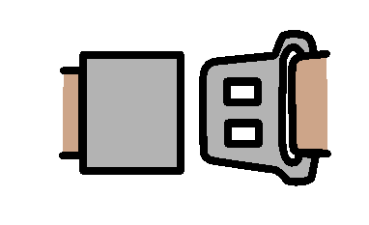
Eddy will get on the bus and
put his seatbelt on.
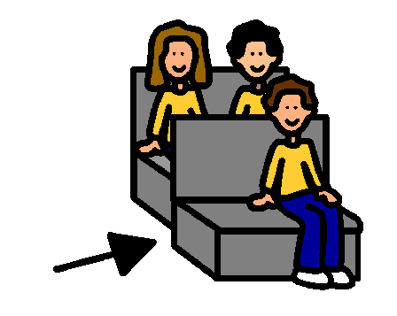
Eddy will sit quietly in the bus.
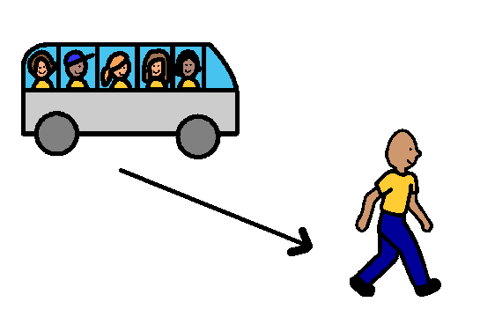
Eddy will get out of the bus when asked.

Eddy will walk quietly into Coles.
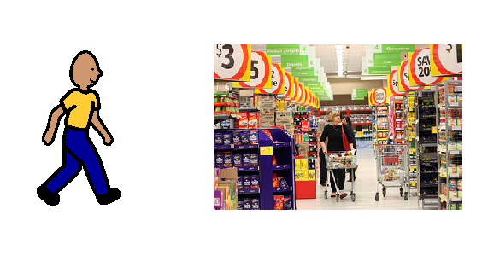
Eddy will walk quietly around
Coles with Mrs O’Sullivan.
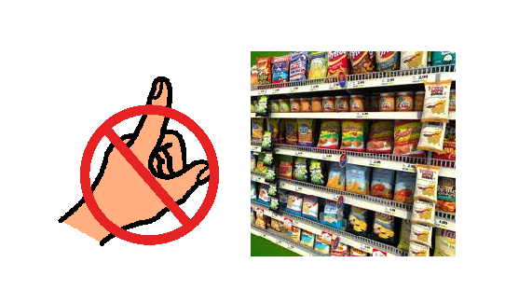
Eddy will not touch anything in Coles
unless Mrs O’Sullivan asks him to.
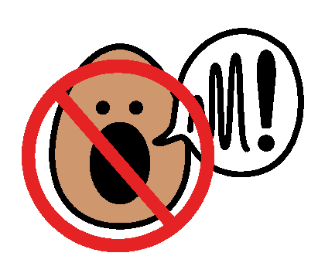
If Eddy yells at Coles he will sit in the bus.
If Eddy cries at Coles he will sit in the bus.
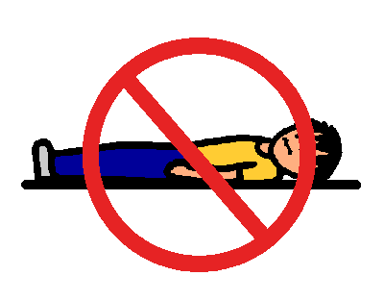
If Eddy throws himself on the ground
at Coles he will sit in the bus.
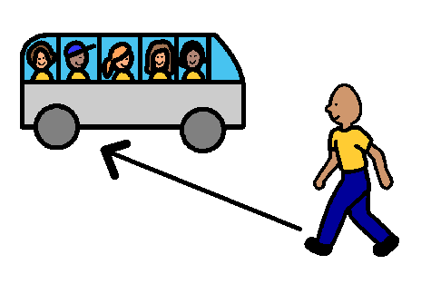
When Coles shopping is finished
Eddy will walk to the bus.
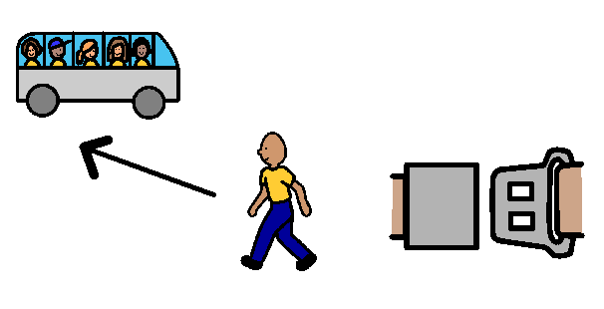
Eddy will get in the bus
and put his seatbelt on.
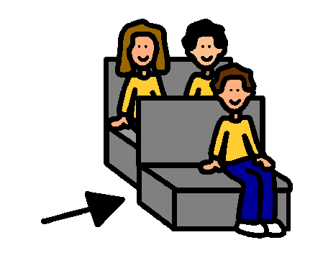
Eddy will sit quietly in the bus.
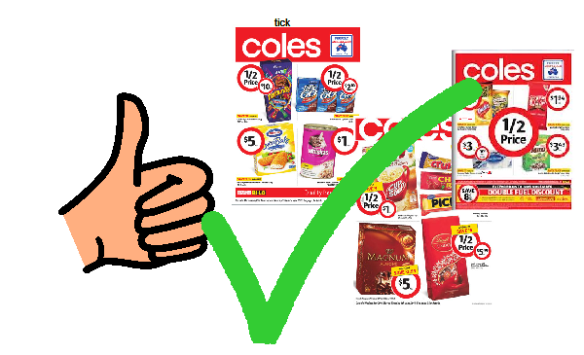
If Eddy is good at Coles
he will get some Coles catalogues.

